COFFEE SHOP SALES ANALYSIS

A Business Intelligence Project
Tools Used:
• Excel
• Power BI
• Tableau

Prepared By:
Kumar Jyotiraditya

Date:
01-06- 2026

Table of Contents
1. Introduction
2. Business Problem Statement
3. Project Objectives
4. Dataset Description
5. Data Preparation
6. Methodology
7. Dashboard Overview
8. Key Insights
9. Business Recommendations
10. Conclusion

Introduction

The Coffee Shop Sales Analysis project was developed to analyze sales performance across multiple store locations and identify customer purchasing patterns. The project leverages Excel, Power BI, and Tableau to transform raw transactional data into meaningful business insights.

The analysis focuses on revenue generation, transaction trends, quantity sold, hourly sales behavior, and store performance. The final dashboards provide management with an interactive tool to support data-driven decision-making.

Business Problem Statement
Coffee shop management lacked a centralized system to monitor sales trends, peak operating hours, and store performance. Without data-driven insights, it becomes difficult to optimize staffing, inventory planning, and promotional strategies.

The objective of this project is to analyze sales data and identify opportunities to improve operational efficiency and revenue performance.

Project Objectives
• Analyze overall sales performance

• Identify peak revenue-generating hours

• Compare store-wise performance

• Understand customer purchasing behavior

• Evaluate sales across different time periods

• Generate actionable business recommendations

Dataset Description
Dataset Name: Coffee Shop Sales Dataset
Key Fields:
• Transaction ID
• Transaction Date
• Transaction Time
• Store Location
• Product Category
• Product Detail
• Quantity Sold
• Unit Price
• Revenue

Total Records: 149,116 Transactions

Store Locations:
• Astoria
• Hell's Kitchen
• Lower Manhattan

METHODOLOGY
The project followed a structured Business Intelligence workflow to transform raw transactional data into actionable business insights.
Step 1: Data Collection
The coffee shop sales dataset containing transaction-level information was collected and imported into Excel for initial exploration.
Step 2: Data Cleaning and Preparation
• Removed missing and inconsistent values
• Standardized date and time formats
• Validated transaction records
• Created additional fields such as Hour and Time Bucket
Step 3: Exploratory Data Analysis
Excel pivot tables and summary statistics were used to understand sales trends, store performance, and customer purchasing behavior.
Step 4: Dashboard Development
Interactive dashboards were developed using Power BI and Tableau to visualize:
• Revenue Performance
• Transaction Trends
• Quantity Sold
• Store Performance
• Time-Based Analysis
• Operational Heatmaps
Step 5: Insight Generation
Key business insights were identified by analyzing sales patterns, customer demand, and store-level performance.
Step 6: Recommendation Development
Business recommendations were formulated based on dashboard findings to improve revenue, operational efficiency, and customer experience.

DASHBOARD OVERVIEW
The project includes interactive dashboards developed in both Power BI and Tableau to provide a comprehensive view of coffee shop performance.
Dashboard Components:
- KPI Dashboard
• Total Revenue
• Total Transactions
• Total Quantity Sold
• Average Order Value
- Revenue Analysis Dashboard
• Revenue by Hour
• Revenue by Time Bucket
• Revenue Trend Analysis
- Transaction Analysis Dashboard
• Transactions by Hour
• Customer Activity Analysis
- Store Performance Dashboard
• Revenue by Store
• Transactions by Store
• Quantity Sold by Store
- Operational Heatmap Dashboard
• Revenue concentration by Hour and Store Location
• Peak business period identification
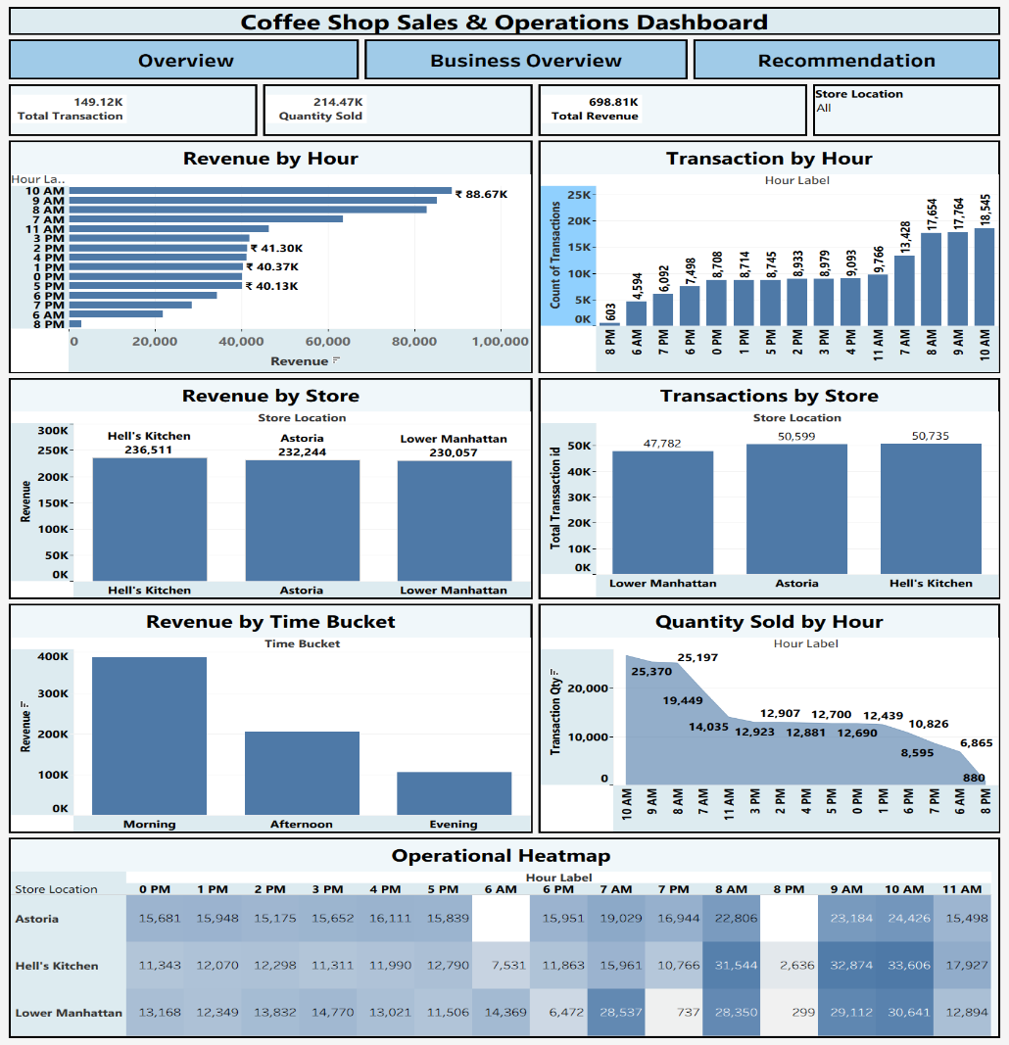

KEY INSIGHTS
The analysis revealed several important business findings:
• Morning hours generated the highest revenue and customer activity across all store locations.
• Peak business activity occurred between 8 AM and 10 AM, indicating the most critical operating period for the coffee shop.
• Hell's Kitchen emerged as the highest-performing store location in terms of overall revenue generation.
• Revenue and transaction volumes showed a consistent decline during evening hours.
• Product demand patterns remained strongest during morning operating hours.
• Heatmap analysis indicated that sales activity was concentrated within a few high-performing time windows, highlighting opportunities for resource optimization.
• Store-level performance differences suggest that operational best practices from top-performing stores can be replicated across other locations.
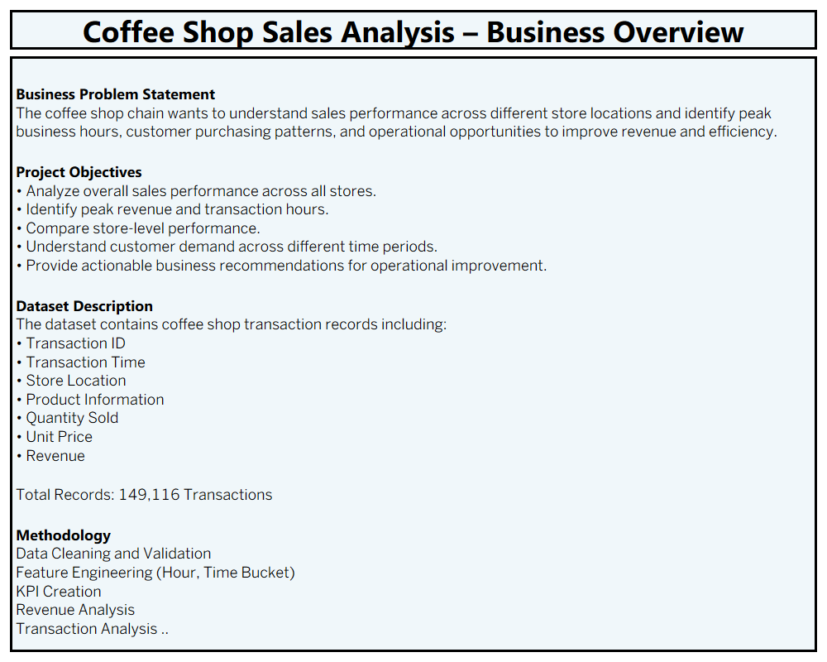
BUSINESS RECOMMENDATIONS
Morning Sales Optimization
• Increase staffing during peak demand periods between 8 AM and 10 AM.
• Ensure inventory replenishment before store opening.
• Prioritize high-demand products during morning hours.
Impact:
Improves customer service efficiency and reduces waiting time.
Store Performance Enhancement
• Analyze successful operational practices at the highest-performing store.
• Replicate effective sales and merchandising strategies across all locations.
Impact:
Improves consistency in store performance and revenue generation.
Evening Revenue Improvement
• Introduce promotional campaigns during low-demand periods.
• Launch loyalty rewards and combo offers to stimulate sales.
Impact:
Increases customer engagement and improves off-peak revenue.
Inventory Optimization
• Align inventory planning with hourly sales patterns.
• Maintain adequate stock levels for high-demand products.
Impact:
Reduces stock shortages and inventory wastage.
Workforce Planning
• Schedule staff according to demand trends.
• Optimize workforce allocation during peak and off-peak periods.
Impact:
Improves operational efficiency and controls labor costs.
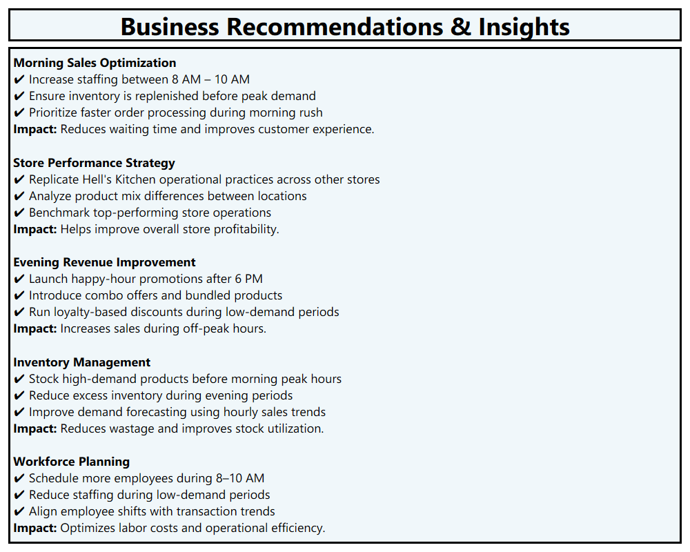
CONCLUSION
The Coffee Shop Sales Analysis project successfully transformed transactional sales data into meaningful business insights through the use of Excel, Power BI, and Tableau.
The analysis identified peak revenue periods, customer purchasing behavior, and store performance variations. Interactive dashboards enabled efficient monitoring of business performance and supported data-driven decision-making.
The recommendations generated from the analysis provide actionable strategies for improving revenue, optimizing staffing, enhancing inventory management, and increasing operational efficiency.
This project demonstrates the practical application of Business Intelligence tools in solving real-world business problems and delivering measurable value through data analytics.

